Bytewise Task 1:

Git version:

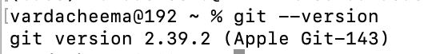

(Already installed)

Git init command:

Git status command:
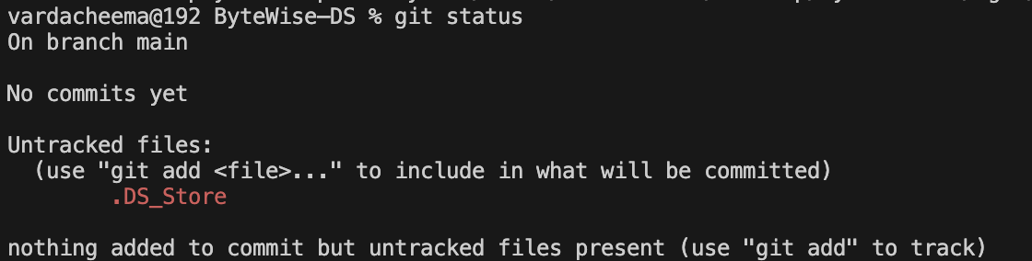

Git add command:

Git commit command:
